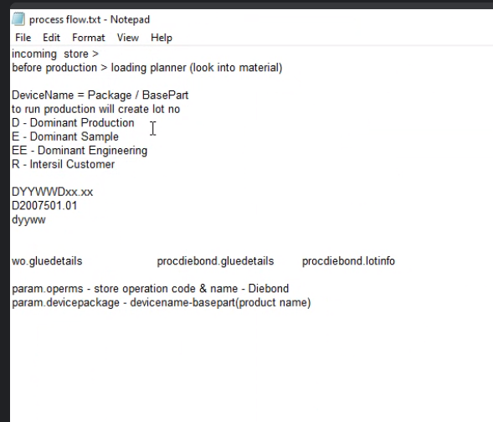

Burhan – link support . retrace data

Dean , ho , tommy

Under Derp_param

select * from OperMS

list of operation , need the database name and table here

OperCode OperDesc OperAbbv Cdt Udt ActiveFlag OpnIndicator OperDBS OperTbl OperGroup OperStage

150 Laser Mark NULL 2014-04-29 15:10:07.000 NULL Y Standard WO LotInfo 0 200



